Quiz 4

Nicholas Colonna

2/7/2018

# Assuming the number of phone call arriving to a switching board is distributed according to a Poisson distribution with the parameter lambda equaling 3 calls/minutes. Suppose I observe the switching board for 10 minutes. We want to investigate the probability that there exists an inter-arrival time greater than a time interval denoted t. To estimate this, follow the steps:

#1. Draw a random number k from the Poisson distribution corresponding to the 10 minute interval.  
k <- rpois(1,30)  
k

## [1] 27

#2. Draw k random numbers from the Uniform distribution U(0, 10) - these are the arrival times for those k events.  
randomNums <- runif(k,0,10)  
randomNums

## [1] 7.3215792 9.8748624 7.5161281 4.4890378 6.9499495 8.2653589 0.4828851  
## [8] 9.9545441 6.2195892 1.3826201 1.5785788 9.8740744 2.0861676 5.7719633  
## [15] 5.4027395 0.7408363 0.5283244 3.5908121 3.1466822 8.8222016 4.4890148  
## [22] 8.4267958 7.5100676 2.6347053 7.4423831 6.4603214 8.5919756

#3. Sort the random times in step 2 from low to high.  
sortedNums <- sort(randomNums)  
sortedNums

## [1] 0.4828851 0.5283244 0.7408363 1.3826201 1.5785788 2.0861676 2.6347053  
## [8] 3.1466822 3.5908121 4.4890148 4.4890378 5.4027395 5.7719633 6.2195892  
## [15] 6.4603214 6.9499495 7.3215792 7.4423831 7.5100676 7.5161281 8.2653589  
## [22] 8.4267958 8.5919756 8.8222016 9.8740744 9.8748624 9.9545441

#4. Create a function that will take as input the arrival times from 3 and will output the smallest and the largest time interval between these consecutive arrivals.   
intervals <- vector()  
i <- 1  
while(i <= length(sortedNums)){  
 if(i==1){  
 intervals[i] <- sortedNums[i]  
 }else{  
 intervals[i] <- sortedNums[i] - sortedNums[i-1]  
 }  
 i <- i + 1  
}  
intervals #Intervals

## [1] 4.828851e-01 4.543933e-02 2.125119e-01 6.417838e-01 1.959587e-01  
## [6] 5.075888e-01 5.485377e-01 5.119769e-01 4.441299e-01 8.982027e-01  
## [11] 2.304558e-05 9.137017e-01 3.692238e-01 4.476259e-01 2.407322e-01  
## [16] 4.896281e-01 3.716297e-01 1.208039e-01 6.768455e-02 6.060479e-03  
## [21] 7.492308e-01 1.614369e-01 1.651798e-01 2.302261e-01 1.051873e+00  
## [26] 7.879199e-04 7.968169e-02

max(intervals) #Largest Inverval

## [1] 1.051873

min(intervals) #Smallest Interval

## [1] 2.304558e-05

#5. Apply the function for 10,000 generated sequences. Create a histogram for each the smallest inter-arrival time and the largest inter-arrival time. What is the estimate for the expected smallest inter-arrival and largest inter-arrival. (Hint: How do one estimates expectations?)  
minVals <- vector()  
maxVals <- vector()  
test1 <- 0 #Counts all values that are less than 0.3  
test2 <- 0 #Counts all values that are not greater than 0.5  
  
for(i in 1:10000){  
 large.random <- sort(runif(k,0,10))  
 large.intervals <- vector()  
 j <- 1  
 while(j <= length(large.random)){  
 if(j==1){  
 large.intervals[j] <- large.random[j]  
 }else{  
 large.intervals[j] <- large.random[j] - large.random[j-1]  
 }  
   
 if(large.intervals[j] < 0.3){ #Helps find probability for problem 6   
 test1 <- test1 + 1  
 }  
 if(large.intervals[j] <= 0.05){ #Helps find probability for problem 6  
 test2 <- test2 + 1  
 }  
 j <- j+1  
 }  
   
 minVals[i] <- min(large.intervals)  
 maxVals[i] <- max(large.intervals)  
}  
  
mean(minVals) #Estimate for expected smallest interval

## [1] 0.01336585

hist(minVals)

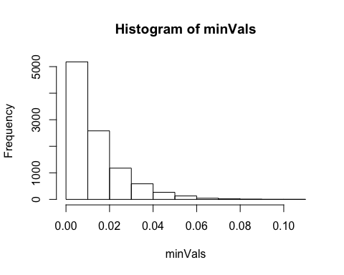

mean(maxVals) #Estimate for expected largetst interval

## [1] 1.387198

hist(maxVals)

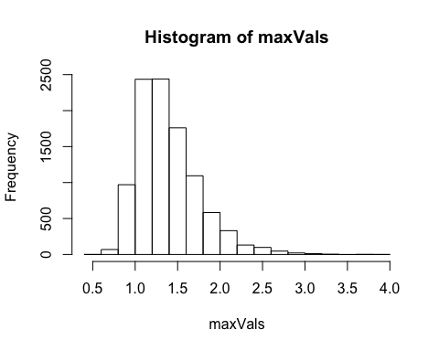

#6. Based on your results what is the probability that at least one inter-arrival time is greater than 0.3? What is the probability that all inter-arrival times are greater than 0.05.  
  
p1 <- 1 - (sum(test1) / (k*10000))  
p1

## [1] 0.4403889

p2 <- 1- (sum(test2) / (k*10000))  
p2

## [1] 0.8746889